MS SQL QUERIES FOR PIZZA SALES

1. Total Revenue:

select COUNT(DISTINCT order_id) as Total_Orders from pizza_sales

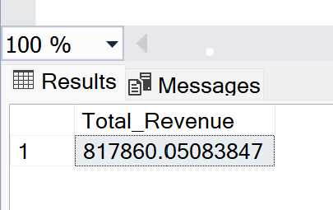

1. Average Order Value:

select SUM(total_price)/ count(DISTINCT order_id) as Average_Order_Value from pizza_sales

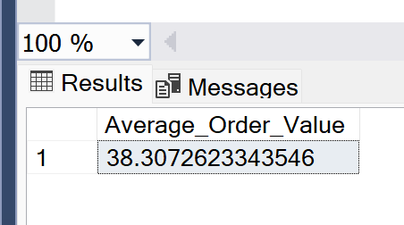

1. Total Pizza’s Sold:

select SUM(quantity) as Total_Pizza_Sales from pizza_sales

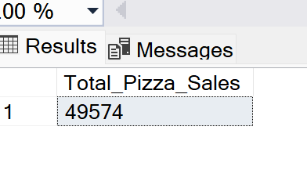

1. Total Orders:

select COUNT(DISTINCT order_id) as Total_Orders from pizza_sales

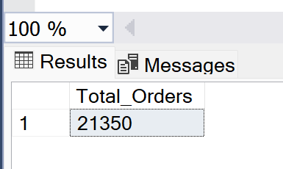

1. Average Pizza’s Per Order:

select CAST (SUM(quantity) as decimal(10,2))/ CAST (COUNT( DISTINCT order_id)as decimal(10,2)) as Average_Pizzas_per_order from pizza_sales

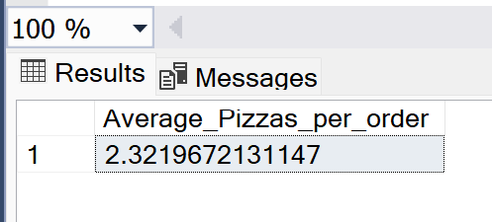

1. Total Sales by order of Weekdays:

select DATENAME(DW, order_date) as Weekdays, count(distinct order_id) as Total_Sales from pizza_sales group by DATENAME(DW, order_date)

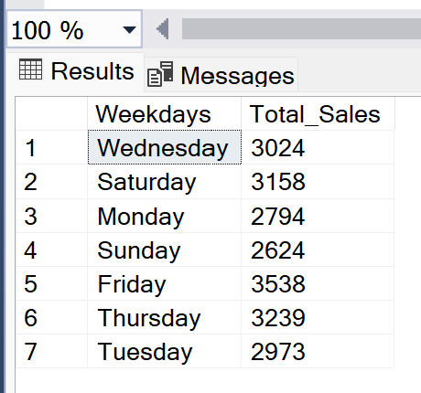

1. Total sales by Month:

SELECT DATENAME(MONTH, order_date) as Month, COUNT(DISTINCT order_id) AS Total_Sales FROM pizza_sales GROUP BY DATENAME(MONTH, order_date)

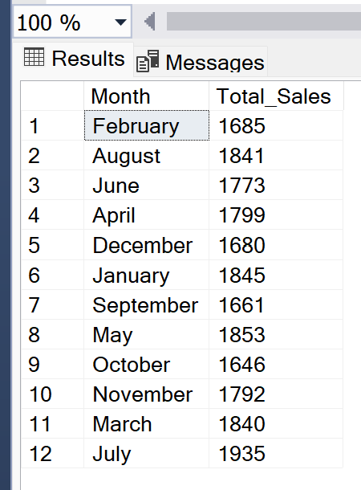

1. Sales % by Pizza Category:

SELECT pizza_category, SUM(total_price)*100/(SELECT SUM(total_price) from pizza_sales) AS PCT FROM pizza_sales

GROUP BY pizza_category

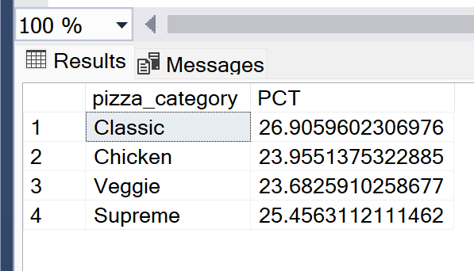

1. Sales % by Pizza Size:

SELECT pizza_size, cast(sum(total_price) as decimal(10,3))as Total_Sales, cast(sum(total_price)*100/(select sum(total_price) from pizza_sales)as decimal(10,2)) as PCT from pizza_sales

group by pizza_size

order by PCT desc

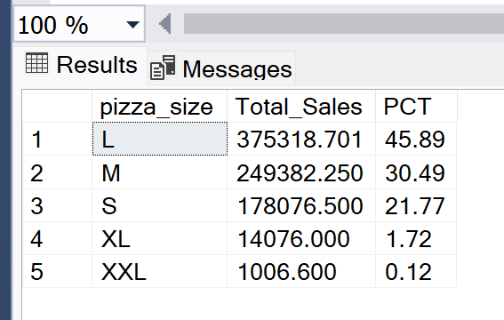

1. Top 5 Pizzas by Revenue:

select top 5 pizza_name, sum(total_price) as Total_Revenue from pizza_sales

group by pizza_name

order by Total_Revenue DESC

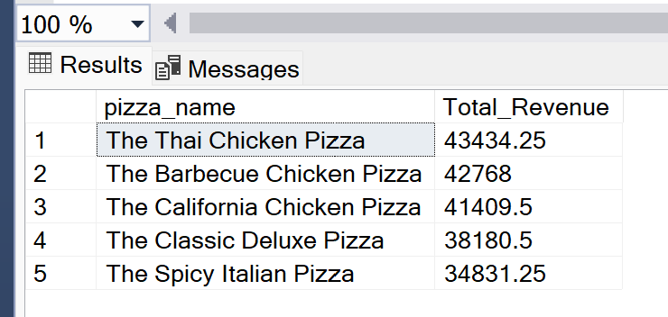

1. Bottom 5 Pizzas by Revenue:

select top 5 pizza_name, sum(total_price) as Total_Revenue from pizza_sales

group by pizza_name

order by Total_Revenue

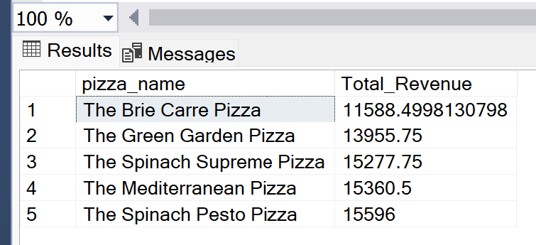

1. Top 5 Pizzas by Quantity:

select top 5 pizza_name, sum(quantity) as Quantity from pizza_sales

group by pizza_name

order by Quantity desc

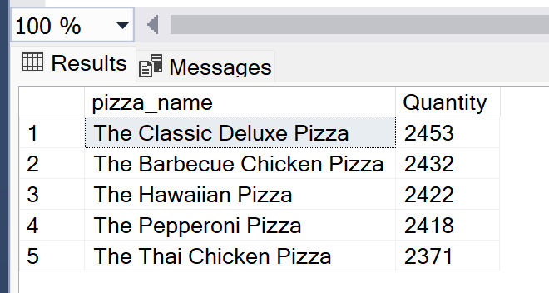

1. Bottom 5 Pizzas by Quantity:

select top 5 pizza_name, sum(quantity) as Quantity from pizza_sales

group by pizza_name

order by Quantity

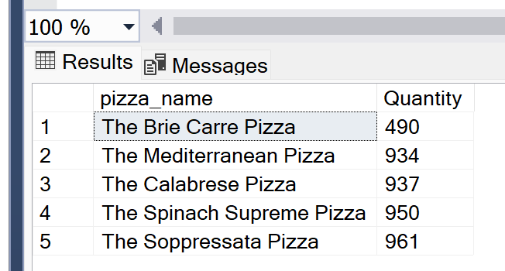

1. Top 5 Pizzas by Orders:

select top 5 pizza_name, count(distinct order_id) as Orders from pizza_sales

group by pizza_name

order by Orders desc

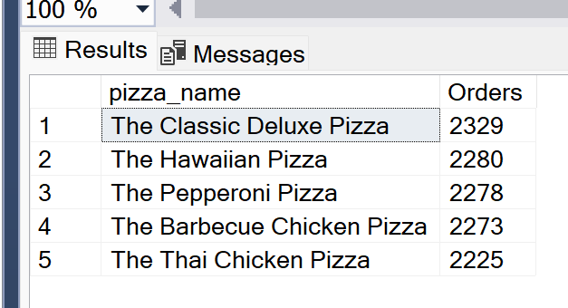

1. Bottom 5 Pizzas by Order:

select top 5 pizza_name, count(distinct order_id) as Orders from pizza_sales

group by pizza_name

order by Orders

